**Question 4**

$${ES}_{c}\left(X\right)= E\left[X \right| X≤{VaR}_{c}(X)]$$

Before any maths, it’s good to know more about the Normally Distributed assumption for the random variable, that has a graphic like the next

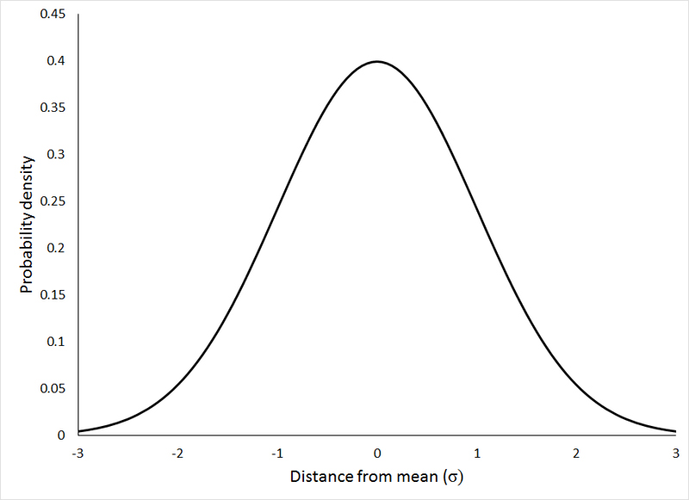

The Value at Risk is the value separating common losses from the worst losses (the ones bigger than the Value at Risk) similarly, from the return optical, the Value at Risk separes common returns from the worst returns (the ones less than the Value at Risk). So, one, and just one, value of the x axis of the above figure is the Value at Risk, and to this case ${VaR}_{c}(X)$ is a value less than zero. Expected Shortfall is the average of the losses that lies bigger than the calculated Value at Risk, or the average of returns that lies less than the calculated Value at Risk. Here, we’re analysing the return (R(x)) optical, opposite to losses optical (L(x)).

Translating these definitions to maths, the Expected Shortfall will be the probability of having worst returns than the Value at Risk (probability distribution function to normal distribution from minus infinity to the VaR) times the return (u) divided by the area that defines these values (1 - c), so the result will be an average:

$${ES}_{c}\left(X\right)= E\left[X \right| X≤{VaR}_{c}(X)]= \frac{1}{1-c}.\int_{-∞}^{{VaR}_{c}(X)}{u.\frac{1}{σ.\sqrt{2π}}.e^{\left(-\frac{1}{2}.\frac{{(u-μ)}^{2}}{σ^{2}}\right)}.du}$$

Other assumption is that ${VaR}_{c}(X)$ is equal to $μ+ ɸ^{-1}\left(1-c\right).σ$, so

$${ES}_{c}\left(X\right)= \frac{1}{1-c}.\int_{-∞}^{μ+ ɸ^{-1}\left(1-c\right).σ}{\frac{u}{σ.\sqrt{2π}}.e^{\left(-\frac{1}{2}.\frac{{(u-μ)}^{2}}{σ^{2}}\right)}.du}$$

$${ES}_{c}\left(X\right)= \frac{1}{1-c}.\int_{-∞}^{μ+ ɸ^{-1}\left(1-c\right).σ}{\frac{u}{σ.\sqrt{2π}}.e^{\left(-\frac{1}{2}.{\left(\frac{u-μ}{σ}\right)}^{2}\right)}.du}$$

Changing the variables, calling t the expression $\frac{u-μ}{σ}$:

* The differential will be:
$$t= \frac{u-μ}{σ}$$

$$t= \frac{u}{σ}- \frac{μ}{σ}$$

$$dt= d\frac{u}{σ}- d\frac{μ}{σ}$$

$$dt= d\frac{u}{σ}$$

$$du= σ.dt$$

* The superior extreme will be:

$$t= \frac{u-μ}{σ}$$

$$u= σ.t+ μ$$

$$u= μ+ ɸ^{-1}\left(1-c\right).σ$$

$$σ.t+ μ= μ+ ɸ^{-1}\left(1-c\right).σ$$

$$t= ɸ^{-1}\left(1-c\right)$$

And the inferior extreme will maintain. So, the new equation is:

$${ES}_{c}\left(X\right)= \frac{1}{1-c}.\int_{-∞}^{ɸ^{-1}\left(1-c\right)}{\frac{μ+ σ.t}{σ.\sqrt{2π}}.e^{\left(-\frac{1}{2}.t^{2}\right)}.σ.dt}$$

$${ES}_{c}\left(X\right)= \frac{1}{1-c}.\int_{-∞}^{ɸ^{-1}\left(1-c\right)}{\frac{(μ+ σ.t)}{\sqrt{2π}}.e^{\left(-\frac{1}{2}.t^{2}\right)}.dt}$$

$${ES}_{c}\left(X\right)= \frac{1}{1-c}.\left[\int_{-∞}^{ɸ^{-1}\left(1-c\right)}{\frac{μ}{\sqrt{2π}}.e^{\left(-\frac{1}{2}.t^{2}\right)}.dt}+\int_{-∞}^{ɸ^{-1}\left(1-c\right)}{\frac{σ.t}{\sqrt{2π}}.e^{\left(-\frac{1}{2}.t^{2}\right)}.dt} \right]$$

$${ES}_{c}\left(X\right)= \frac{1}{1-c}.\left[\frac{μ}{\sqrt{2π}}.\int_{-∞}^{ɸ^{-1}\left(1-c\right)}{e^{\left(-\frac{1}{2}.t^{2}\right)}.dt}+\frac{σ}{\sqrt{2π}}\int_{-∞}^{ɸ^{-1}\left(1-c\right)}{t.e^{\left(-\frac{1}{2}.t^{2}\right)}.dt} \right]$$

Calculating the integrals separately:

To the first integral:

$$\int_{-∞}^{ɸ^{-1}\left(1-c\right)}{e^{\left(-\frac{1}{2}.t^{2}\right)}.dt}$$

To the other integral:

$$\int_{-∞}^{ɸ^{-1}\left(1-c\right)}{t.e^{\left(-\frac{1}{2}.t^{2}\right)}.dt}$$

Saying that $u= -\frac{1}{2}.t^{2}$, $du$ is

$$du= -\frac{1}{2}.2.t.dt$$

$$-du= t.dt$$

$$\int_{-∞}^{ɸ^{-1}\left(1-c\right)}{t.e^{\left(-\frac{1}{2}.t^{2}\right)}.dt= }\int_{-∞}^{ɸ^{-1}\left(1-c\right)}{e^{\left(-\frac{1}{2}.t^{2}\right)}.t.dt=\int_{-∞}^{ɸ^{-1}\left(1-c\right)}{e^{\left(u\right)}.(-du)} }$$

$$\int_{-∞}^{ɸ^{-1}\left(1-c\right)}{t.e^{\left(-\frac{1}{2}.t^{2}\right)}.dt= }-\int_{-∞}^{ɸ^{-1}\left(1-c\right)}{e^{\left(u\right)}.du}=[-e^{\left(u\right)}]_{-∞}^{ɸ^{-1}\left(1-c\right)}$$

$$\int_{-∞}^{ɸ^{-1}\left(1-c\right)}{t.e^{\left(-\frac{1}{2}.t^{2}\right)}.dt= }-[e^{\left(ɸ^{-1}\left(1-c\right)\right)}- e^{\left(-∞\right)}]$$

Where $e^{\left(-∞\right)}$ tends to zero, so:

$$\int_{-∞}^{ɸ^{-1}\left(1-c\right)}{t.e^{\left(-\frac{1}{2}.t^{2}\right)}.dt= -e^{\left(ɸ^{-1}\left(1-c\right)\right)}}$$

https://sciences.usca.edu/biology/zelmer/305/norm/